CENTRO DE INVESTIGACIÓN Y DOCENCIA ECONÓMICAS, A.C.



COVID-19 MORTALITY EXCESS AND COST-EFFECTIVE ANALYSIS OF DIFFERENT TREATMENTS

TESINA

PARA OBTENER EL GRADO DE

MAESTRÍA EN MÉTODOS PARA EL ANÁLISIS DE POLÍTICAS PÚBLICAS

PRESENTA

HIRVIN AZAEL DIAZ ZEPEDA

DIRECTOR DE LA TESIS: DR. FERNANDO ALARID ESCUDERO

AGUASCALIENTES 2021

**Introduction**

COVID-19 pandemic has created a global public health crisis. Its impact on Mexico has been particularly severe. On March 21, 2021, the Mexican government reported 2,238,887 accumulated cases of COVID-19 and 203,210 deaths1, making Mexico the fourteenth country in the world in confirmed cases and the third in reported deaths.2

Excess mortality from a specific disease is a useful and important measure for decision makers, since it allows them to evaluate different strategies aimed at modifying and mitigating this outcome. To date, no studies have estimated Mexico´s excess mortality due to COVID-19 and used such estimates to evaluate the effectiveness of various COVID-19 strategies. An important advantage of this approach is that it provides an opportunity to analyze policies that have not yet implemented and hence supports decision-making and planning

The aims of this analysis are twofold: 1) to estimate the COVID-19 specific mortality for Mexico’s population aged 45 years and older using relative survival methods; 2) to quantify the effectiveness, costs, and cost-effectiveness of different treatments that aim to reduce the COVID-19-specific mortality using a microsimulation model.

**Methods**

***Data***

We used data from the Mexican National Epidemiological Surveillance System. This dataset includes people tested for SARS-CoV-2 in Mexico and contains only data obtained from tests performed on people who were suspected of infection during stays in the medical units of the health sector3. We analyze data only for people with a positive test result, 45 years of age and older, who were hospitalized. We classify these patients by sex, age group, and whether they were intubated. The National Population Council demographic indicators provide background mortality rates for the Mexican population in 20204.

We use hospitalization costs per day published by the Mexican Social Security Institute5, that provides health care to 60% of the Mexicans6. Health expenditure per year is obtained from World Health Organization Global Health Expenditure database7 and age based utilities from preference EQ-5D scores in United States8.

**Costs**

Costs includes expected daily costs by hospitalization and an estimation of the treatment costs based on information reported by the Mexican Institute of Social Security 5. All costs are reported in Mexican pesos (que año).

**Health Outcomes**

Primary outcomes where (life years, QALY)

Effectiveness is expressed in quality Adjusted Life Years (QALYs) by strategy. To calculate

Calculating QALY (mencionar que lo modelo markov, age and sex specific y que estoy ajustando por age and sex specific utilities)

this, we take the people that survived after the simulated 50 days and added the expected years of life according to their sex and age.

***Relative Survival and Disease-specific Hazard***

We employ the relative survival and excess mortality analysis methodology. The methodology is appropriate when one is studying data on a cohort of people diagnosed with a disease as well as follow-up time and information on vital status but does not have definitive cause of death information.9

Relative survival is expressed as a time-specific ratio between the survival of the cohort analyzed $S_{O}(t)$ and the expected survival of the population $S_{p}(t)$ normally obtained from population mortality information. Relative survival is defined as .9,10 The methodology also allows one to report the overall hazard $λ_{O_{i}}(t)$ over time for the cohort analyzed, which can be written as the sum of the disease-specific hazard $λ_{E_{i}}\left(t\right)$ and the average background population hazard 9.

We extracted the disease-specific hazard from a modified versions of function *relsurv* package of Pohar-Perme11, who proposed an estimator for the *excess* or *disease-specific* *Hazard $λ_{E.}$*

$$S_{E}\left(t\right)=S_{O}\left(t\right)-S_{P}\left(t\right)$$

$$S_{E}\left(t\right)=exp\left\{- ∫λ_{E}\left(u\right)du\right\}$$

$$λ_{E}=\frac{\sum_{i=1}^{N}{{S_{E}}_{i}\left(t\right)λ_{E_{i}}(t)}}{\sum_{i=1}^{N}{{S_{E}}_{i}(t)}}$$

Disease-specific hazard or “excess-hazard” estimates allow one to compute disease-specific mortality rates and then to extrapolate intervention effects derived from RCTs (i.e., hazard rate ratios) in computing survival in the presence of interventions. By deriving the disease-specific mortality rate ($μ_{Dis}$) and the background mortality rate by sex and age ($μ_{SA}$) from $λ_{E_{i}}\left(t\right)$ and $λ_{P_{i}}(t)$, and assuming the hazard is an additive function of each specific mortality rate, the overall mortality rate is then defined as 12: (Ser consistente entre lambdas y Mus)

$$μ_{Ovall}=μ_{Dis}+μ_{SA }$$

Incorporating the effect of an intervention, such as a pharmacological treatment for a disease then involves modifying $μ_{Dis}$. Published Hazard Ratios from clinical trials $(HR_{CT}$), when estimated on the disease-specific hazards, are then applied to the disease-specific mortality rate $μ_{Dis}$ which in turn alters the overall total mortality rate $μ_{Ovall}$: $μ_{Dis}^{*}=μ_{Dis}*HR_{CT}$

$$μ_{Ovall}^{*}=μ_{Dis}^{*}+μ_{SA }$$

***Decision Model***

Using the population of hospitalized Mexican patients testing positive for COVID-19 who were age 45 and older as our cohort along with information on expected mortality in the general population aged 45 and older in 2020, we estimated disease-specific (${\overline{λ}}_{Dis}$) and background hazards for sex and age (${\overline{λ}}_{SA}$) over a 50-day follow-up period from time of diagnosis. These estimates allowed us to calculate daily disease-specific and background mortality probabilities by age group and sex assuming an exponential distribution of the hazard rate at a specific time:

Si define lambda hat overall el denominador solo seria lambda overall

$$P(Die)=1-\exp\left(- {\overline{λ}}_{Ovall}\right)$$

$$P\left(Die from Covid | Die\right)= P\left(Die\right)*\left(\frac{{\overline{λ}}_{Dis}}{{\overline{λ}}_{Ovall} }\right)$$

$$P\left(Die of other causes | Die\right)= P\left(Die\right)*(\frac{{\overline{λ}}_{SA}}{{\overline{λ}}_{Ovall} })$$

Then, we incorporated these outputs into a decision-analytic microsimulation model which follows individuals infected with COVID-19 in Mexico for 50 days. The model also evaluates alternative treatment strategies by incorporating the effects of treatments that have demonstrated mortality reductions for people with Covid-19: Dexamethasone13, Remdesivir14 and Remdesivir with Baricitinib15.

The overall Hazard Ratio of the clinical trials $(oHR_{CT})$ of these treatments was applied to obtain the COVID-19 specific death probabilities under the effect of different drugs:

Because the hazard ratio for Remdesivir and Baricitinib is reported in comparison to a group treated with Remdesivir, the effect of Baricitinib is applied to ${\overline{λ}}_{Dis with Remd}$ which is computed as defined above.

$$P(Die_{Remd})=1-\exp\left(- {\overline{λ}}_{Ovall}*oHR_{Remd}\right)$$

$$P(Die_{Remd \& Bari})=1-\exp\left(- {\overline{λ}}_{Ovall}*oHR_{Remd} *oHR_{Bari}\right)$$

$$P(Die_{Dexa})=1-\exp\left(- {\overline{λ}}_{Ovall}*oHR_{Dexa}\right)$$

The microsimulation model utilized in this analysis is an adaptation of the state-transition microsimulation algorithm proposed for modeling for health decision sciences16. The model includes two health states: Detected with COVID-19 infection during hospitalization and Dead. The model tracks whether those who die do so because of COVID-19 or from other causes.

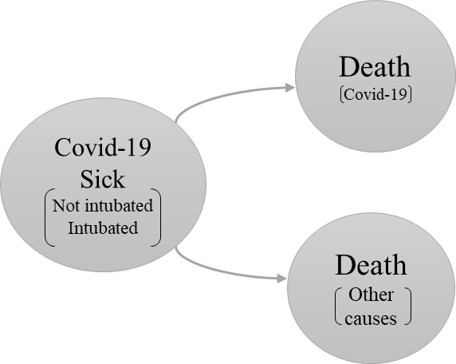

Figure 1 Model structure

Cambiar los titulos de los COVID-19 death, other causes death. Hablar una QALEs based on sex and age.

***Treatments***

Because Dexamethasone is not recommended for non-intubated patients and Remdesivir is a drug that has shown more efficacy in less critical states, the simulated population was divided into two cohorts as the feasible decision alternatives are different in these two groups: Patients who were hospitalized without intubation and patients who were hospitalized and intubated. We carry out a cost-effectiveness analysis for the following strategies: *Treat with Remdesivir*, *Treat with Remdesivir and Baricitinib* and *no treatment* for a cohort of hospitalized patients, not intubated. For intubated patients the strategies are: *Treat with Dexamethasone* and *no treatment*.

Incremental Cost-Effectiveness Ratio (ICER) is incorporated to determine the best strategy for each cohort. The ICER estimation was carried out with *dampack*17package*.* The cost-effectiveness analysis was developed with a probabilistic sensitivity analysis to incorporate uncertainty in the information on the effectiveness of treatments and hospital costs. Supplemental material of this document includes the parameters utilized in the model.

All calculations, models and graphs were done using R,18 and Rstudio software.19

|  |  |  |  |
| --- | --- | --- | --- |
| **Model Values, Utilities and Costs** | | | |
| Cohorts characteristics | | | |
| Hospitalized, not intubated | | | |
| Sex | Age Group | N | Proportion |
| Male | 45 - 54 yo. | 32,154 | 16% |
| 55 -64 yo. | 35,973 | 18% |
| 65 - 69 yo. | 16,133 | 8% |
| 70 + yo. | 34,915 | 17% |
| Female | 45 - 54 yo. | 19,869 | 10% |
| 55 -64 yo. | 24,948 | 12% |
| 65 - 69 yo. | 11,512 | 6% |
| 70 + yo. | 25,189 | 13% |
| Total |  | 200,693 |  |
| Hospitalized, intubated | | | |
| Sex | Age Group | N | Proportion |
| Male | 45 - 54 yo. | 5,898 | 15% |
| 55 -64 yo. | 7,837 | 20% |
| 65 - 69 yo. | 3,838 | 10% |
| 70 + yo. | 7,295 | 19% |
| Female | 45 - 54 yo. | 2,719 | 7% |
| 55 -64 yo. | 4,451 | 11% |
| 65 - 69 yo. | 2,268 | 6% |
| 70 + yo. | 4,578 | 12% |
| Total |  | 38,884 |  |
| Model Assumptions | | | |
| Markov Model COVID-19 Sick - Dead | | | |
| Time horizon | 50 days | | |
| Number of states | 3 | | |
| Name of states | Cov-19 + | | |
| Cov-19 Dead | | |
| Dead Other causes | | |
| Markov Model COVID-19 Alive - Dead | | | |
| Time horizon | Lifetime | | |
| Number of states | 2 | | |
| Name of states | Alive | | |
| Dead | | |
| Discount rate | 0.05 | | |
| Utilities and Costs | | | |
| Cost (2021 Mexican Pesos) $ | | | |
| Treatment |  | Frequency | |
| Remdesivir Treatment | 6,188 | Daily | |
| Baricitinib Treatment | 3,672 | Daily | |
| Dexamethasone treatment | 4 | Daily | |
| Mean Hospitalization costs, not intubated | 9,272 | Daily | |
| Mean Hospitalization costs, intubated | 44,151 | Daily | |
| Healthcare expenditure by patient | 11,483 | Annually | |
| Quality of life | | | |
| Age - Group | | Utilities | |
| 45 - 49 | | 0.871 | |
| 50 - 59 | | 0.842 | |
| 60 - 69 | | 0.823 | |
| 70 - 79 | | 0.79 | |
| ≥ 80 | | 0.736 | |

**Results**

The results show us that the COVID-19 specific hazard practically represents the total hazard, since the daily background population mortality rates are near 0. The highest hazard is around day 10 for hospitalized people, while in the intubated cohort, the high hazard rates remain for more days, extending beyond 20 days for all age groups. For the hospitalized cohort hazard increases at higher ages and is systematically higher for Male sex. Practically all observed hazard decreases to the expected population mortality level after day 40.

However, hazards are practically double for the intubated cohort. Also, the intubated cohort's hazards are very similar after 55 years, and the differences by sex are much less notable. The effect of COVID-19 does not disappear for the last age group, and even on day 60, the mortality levels are higher than expected.

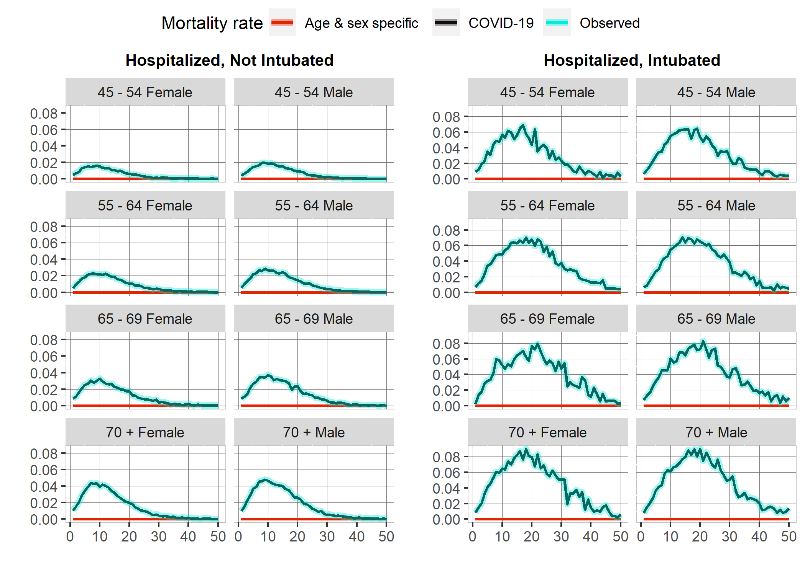

Figure 2: COVID-19 Daily hazards by cohort, age and sex group. Source: Author´s own creation with information published by Mexico´s Ministry of Health.

**Primero describe resultados y luego el PSA. Tengo que checar como describieron el PSA y escribirlo.**

**Probabilistic Sensitivity Analysis**

The cost-effectiveness analyses presented come after having carried out a probabilistic sensitivity analysis with 1,000 sets of parameters. The distribution of parameters is shown in the supplemental material.

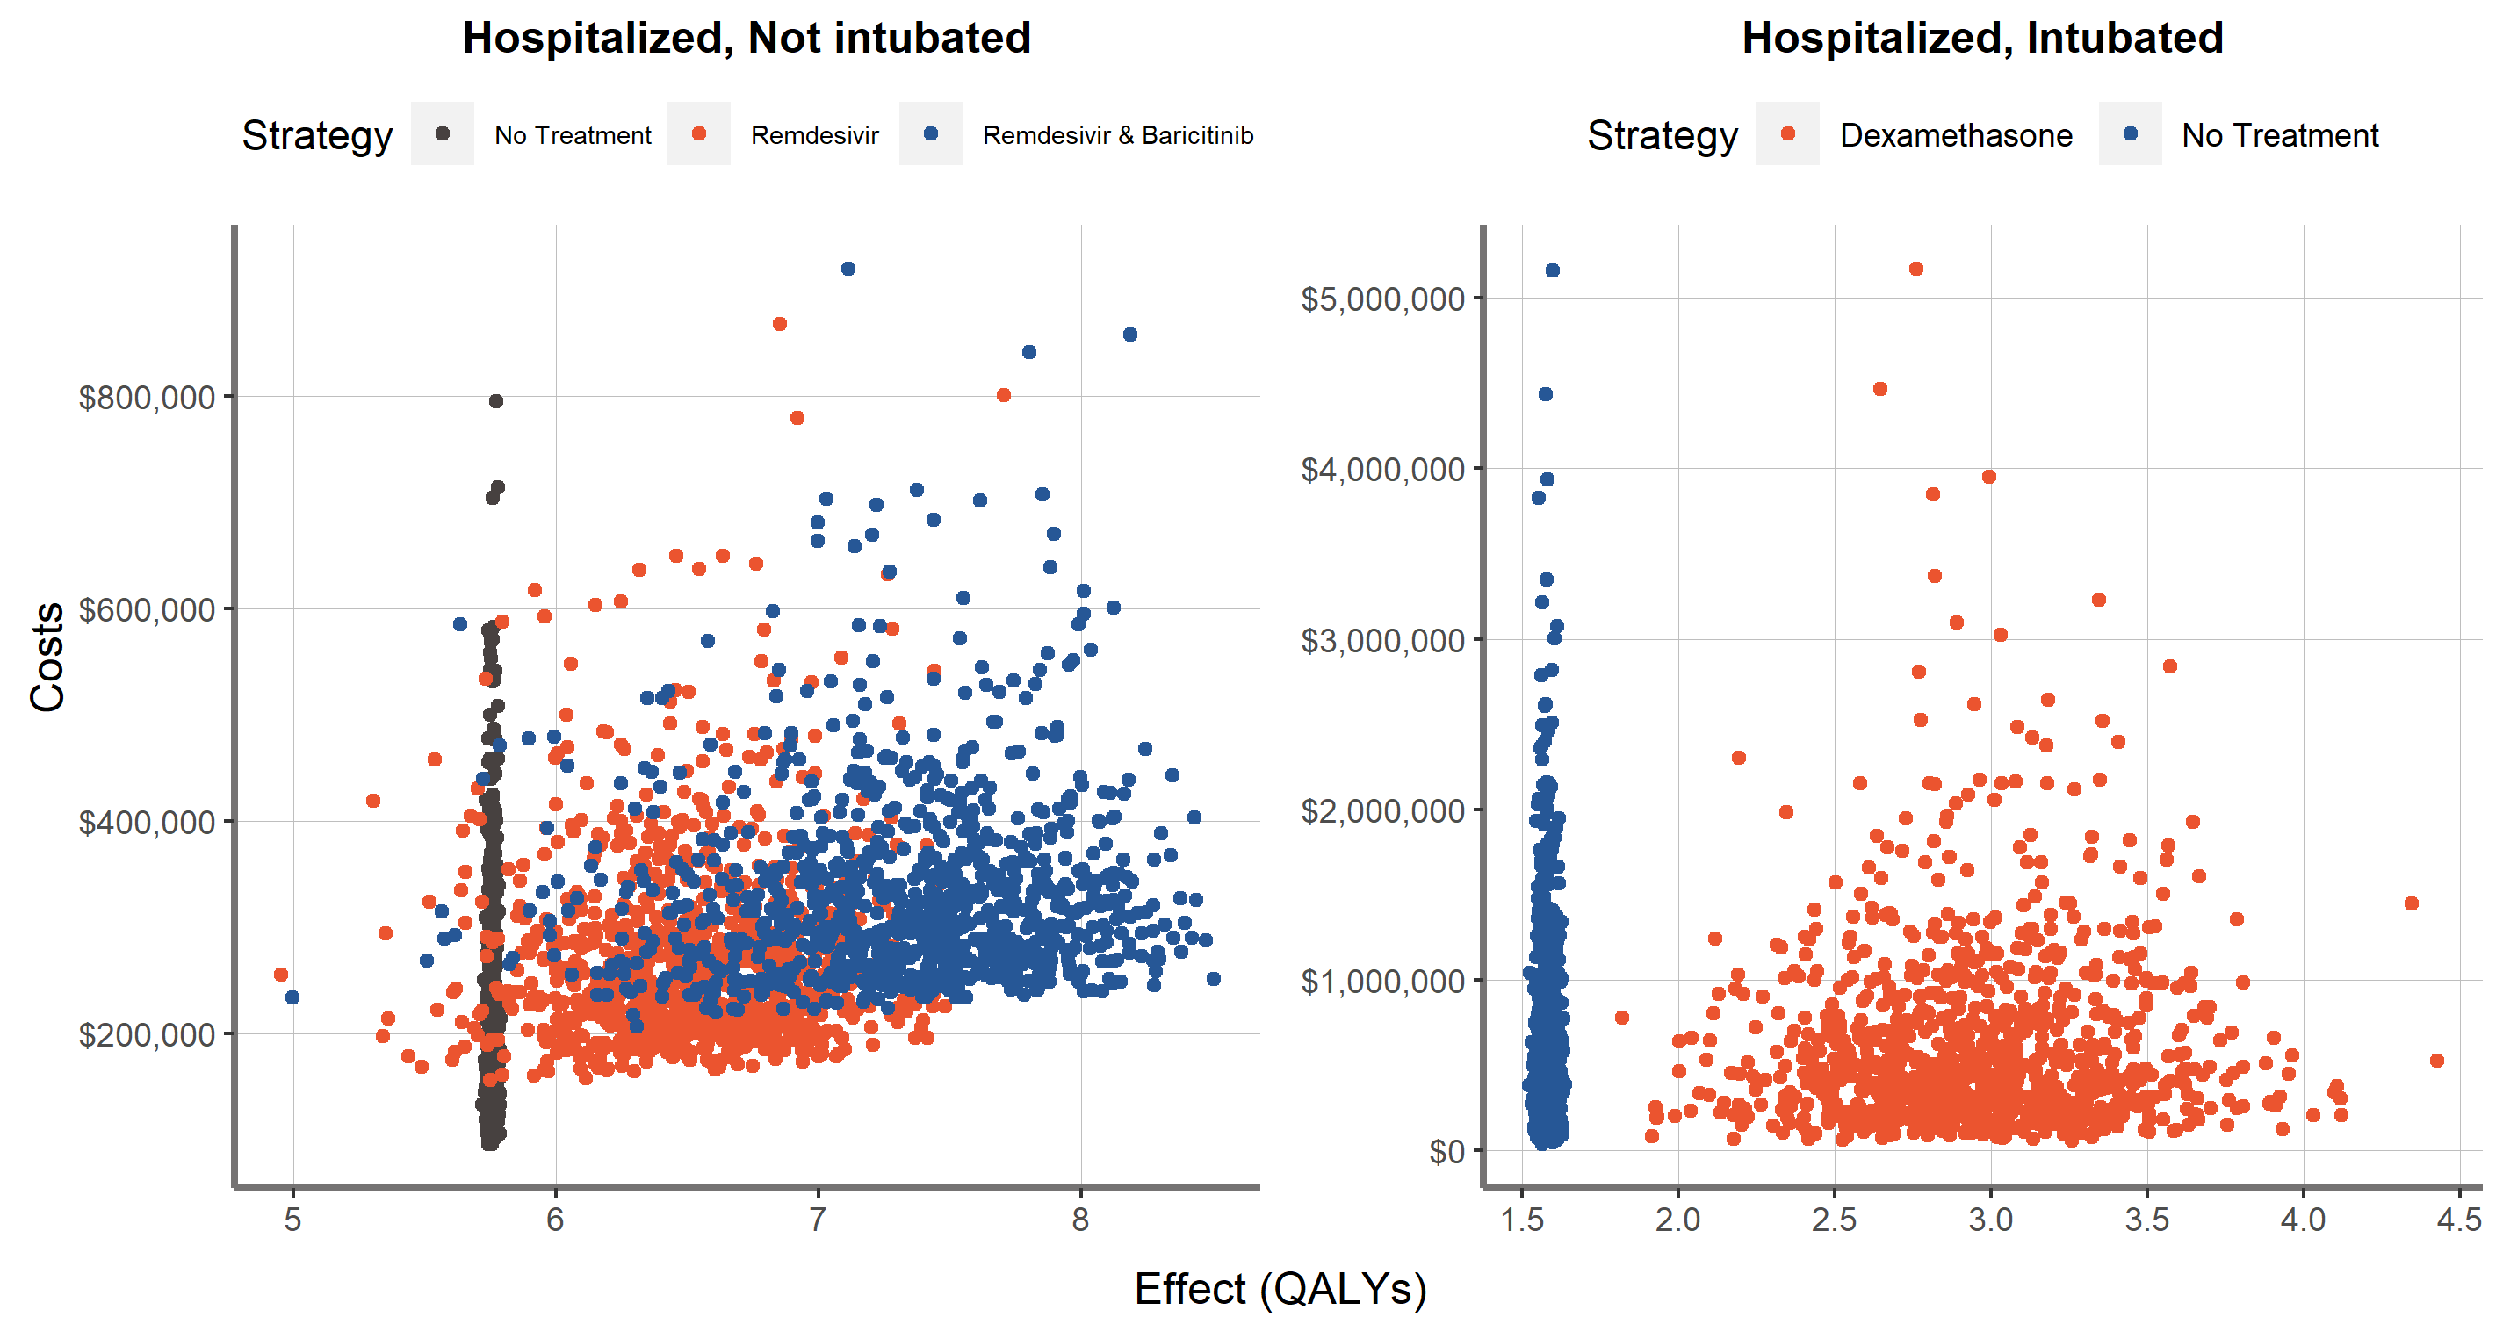

Que tengan el mismo tamaño de letra.

No Treatment siempre va primero.

Explorar si en esta gráfica con una figura, disminuir el Alpha. Poner un punto grande que indique el punto promedio. Si le bajo el Alpha se difumina, y el promedio Alpha 1.

**Health Outcomes and Treatment Costs**

If no treatment is applied, the expected life years are 7.54. When the population is treated with *Baricitinib and Remdesivir* is applied, the expected life years gained are 2.08.

*Treat with Remdesivir* is a weakly dominated strategy as can be seen in the efficient frontier, which implies that the “Remdesivir and Baricitinib” strategy is always chosen if the willingness to pay increases above the “No treatment” limit.

|  |  |  |  |  |  |
| --- | --- | --- | --- | --- | --- |
| Cost-effectiveness results | | | | | |
| Strategy | Costs ($) | QALYs | Incremental Costs | Incremental QALYs | ICERs | |
| Cohort: Hospitalized, Not Intubated | | | | | |
| No treatment | 203,329 | 5.76 |  |  |  | |
| Remdesivir & Baricitinib | 331,725 | 7.32 | 128,396 | 1.565334 | 82,025 | |
| Remdesivir* | 271,403 | 6.51 |  |  |  | |
| Cohort: Hospitalized, Intubated | | | | | |
| No treatment | 614,371 | 1.58 | - |  |  | |
| Dexamethasone | 633,602 | 2.96 | 19,231 | 1.38 | 13,936 | |

Poner guion y que este centrado. Remdesivir poner si está dominado y que tipo de dominancia tiene. Es weakly or dominated by extensión y por que lo estoy usando.

Estimacion por costo promedio para grupo de edad tal que el costo, poner el porcentaje de personas que requieren servicios, y eso me da un proxy.

Proyectas los costos a futuro por inflación.

Sacar las proporciones. Alto a los jóvenes, jóvenes niños.

Incrementar el tamaño de letra y de, podría dividir el eje de las y entre 1000 y ponerlo entre paréntesis, hace mucho espacio.

Figure 3: Efficient Frontier

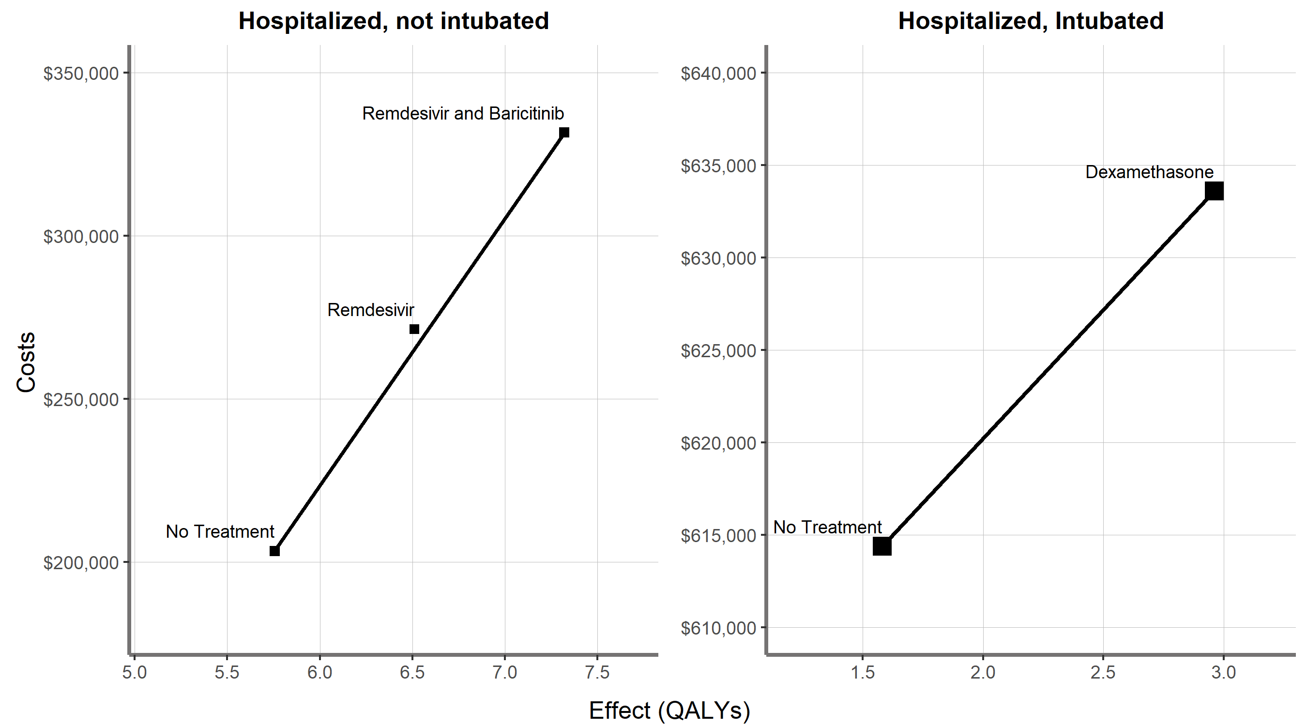

All costs are expresed in Mexican Pesos

The expected Life Years gained by dexamethasone are 1.8. The vast majority of dexamethasone costs come from the increase in individuals who survived the treatment and who saw their hospital costs increase. The price of the drug is meager (approximately 4 Mexican pesos).

In this case, “Dexamethasone” strategy is more cost-effective when the willingness to pay increases over $153,8646 per life year gained.

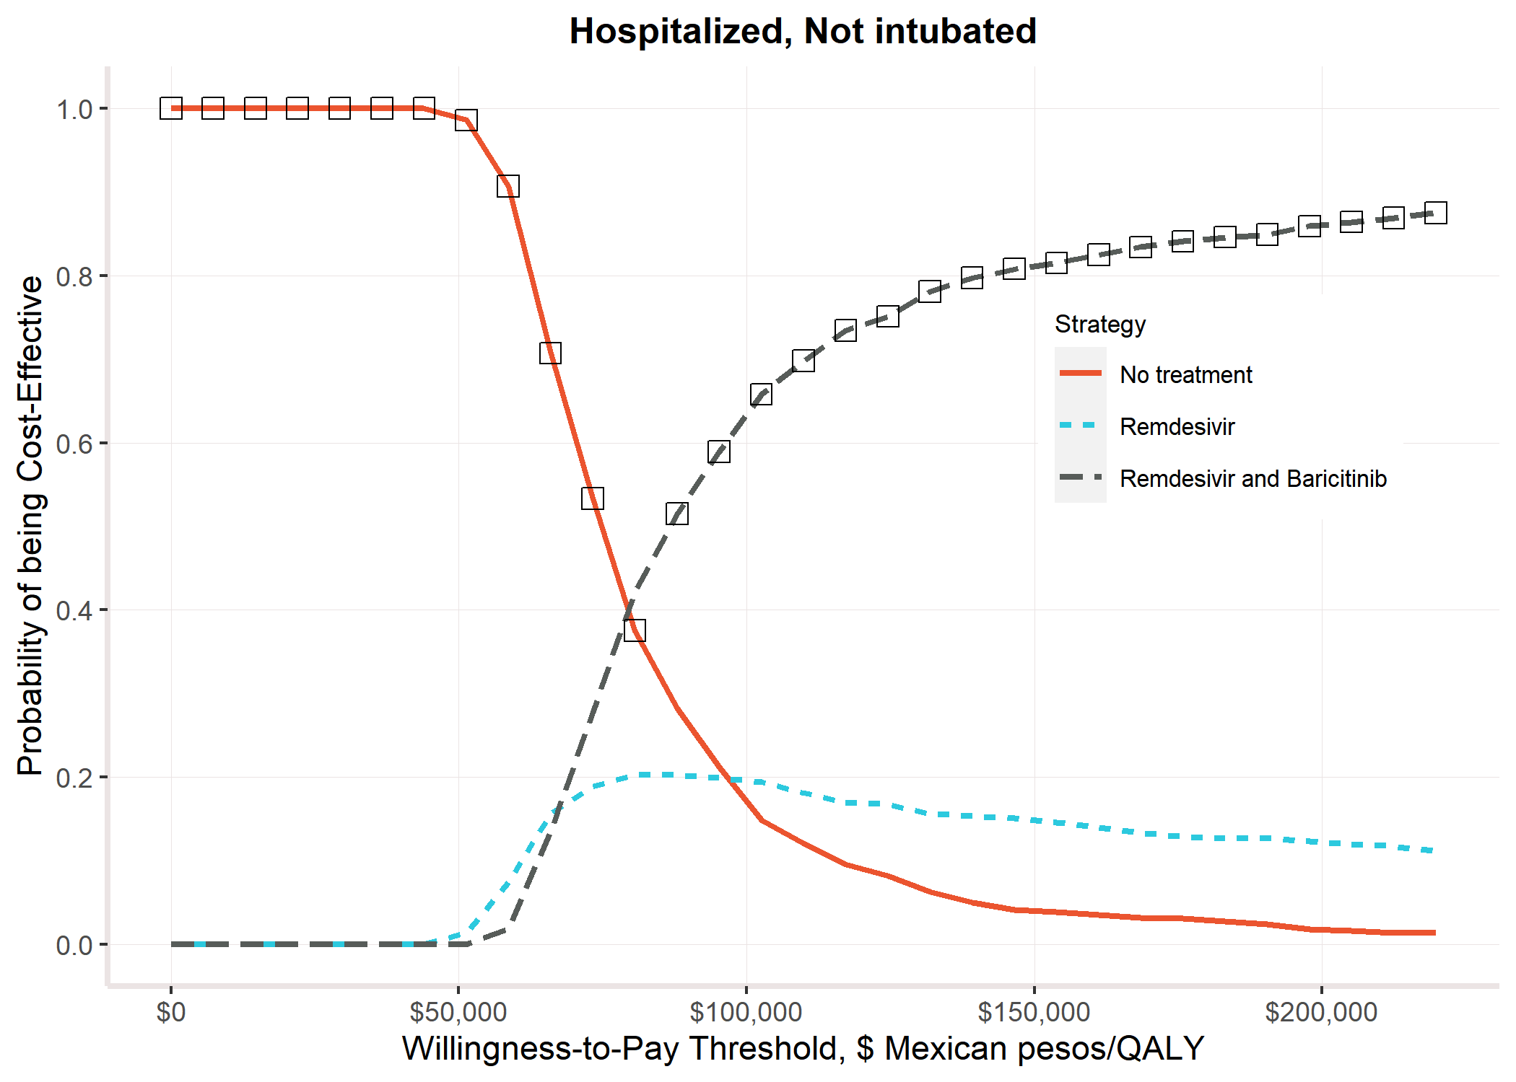

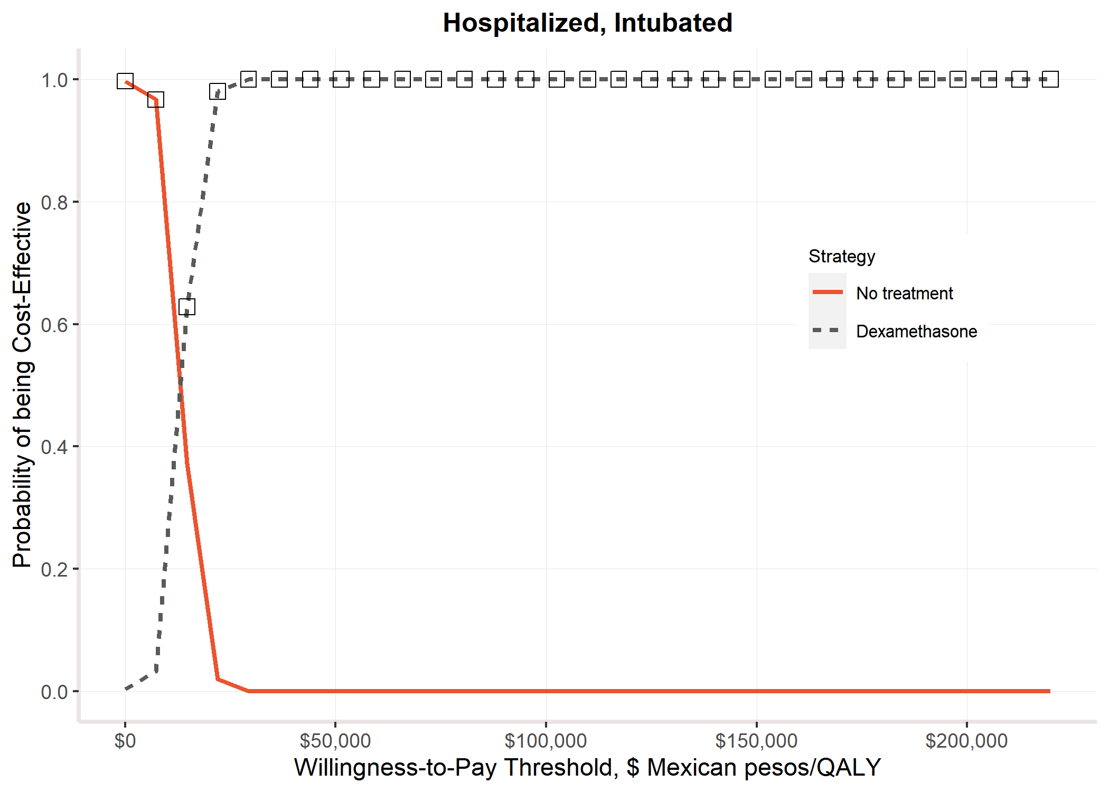

**Discussion**

Primer párrafo resumen breve

Segundo, comparar mis resultados con resultados de otros lados (research in context)

**Key Points for Decision Makers**

**Recomendaciones de política.**

Parrafo de limitaciones

Parrafo fortalezas

**Key Points for Decision Makers**

Parrafo de conclusión.

**References**

1 Secretaria de Salud. Informe Técnico Diario COVID-19 MÉXICO. 2020. https://www.gob.mx/cms/uploads/attachment/file/593517/Comunicado_Tecnico_Diario_COVID-19_2020.11.19.pdf.

2 John Hopkins University. COVID-19 Dashboard by the Center for Systems Science and Engineering (CSSE) at Johns Hopkins University (JHU). 2020. https://coronavirus.jhu.edu/map.html (accessed Dec 9, 2020).

3 Secretaría de Salud. Información referente a casos COVID-19 en México. Bases datos COVID 19 en México. 2020; published online Nov 19. https://datos.gob.mx/busca/dataset/informacion-referente-a-casos-covid-19-en-mexico/resource/3d7fb4a8-5763-4dba-a23f-a20edc7783f7 (accessed Dec 9, 2020).

4 Consejo Nacional de Población (CONAPO). Proyecciones de la Población de los Municipios de México, 2015-2030. 2019; published online Sept 22. https://www.gob.mx/conapo/documentos/proyecciones-de-la-poblacion-de-los-municipios-de-mexico-2015-2030 (accessed Dec 9, 2020).

5 H. Consejo Técnico. Acuerdo relativo a la Aprobación de los Costos Unitarios por Nivel de Atención Médica actualizadas al año 2021. México: Diario Oficial de la Federación, 2020.

6 Gobierno de México. El IMSS atiende a 6 de cada 10 mexicanos. Acercando el IMSS al Ciudad. 2018; published online July. http://www.imss.gob.mx/prensa/archivo/201807/191 (accessed May 13, 2021).

7 The World Bank. Current health expenditures per capita (current $US). 2018. https://data.worldbank.org/indicator/SH.XPD.CHEX.PC.CD?locations=MX.

8 Sullivan PW, Ghushchyan V. Preference-Based EQ-5D Index Scores for Chronic Conditions in the United States. *Med Decis Mak* 2006; **23**: 410–20.

9 Pohar Perme M, Klemen P. Pohar Perme, Pavlič - 2018 - Nonparametric relative survival analysis with the R package relsurv.pdf. *J Stat Softw* 2018; **87**. DOI:https://doi.org/10.18637/jss.v087.i08.

10 EDERER F, AXTELL L, CUTLER S. The relative survival rate: a statistical methodology. *Natl Cancer Inst Monogr* 1961; **6**: 101.

11 Pohar Perme M. Package ‘ relsurv ’. 2018. https://cran.r-project.org/web/packages/relsurv/relsurv.pdf.

12 Alarid-Escudero F, Kuntz KM. Potential Bias Associated with Modeling the Effectiveness of Healthcare Interventions in Reducing Mortality Using an Overall Hazard Ratio. *Pharmacoeconomics* 2020; **38**: 285–96.

13 The RECOVERY Collaborative Group. Dexamethasone in Hospitalized Patients with Covid-19 — Preliminary Report. *N Engl J Med* 2020; : 1–11.

14 Beigel JH, Tomashek KM, Dodd LE, *et al.* Remdesivir for the Treatment of Covid-19 — Final Report. *N Engl J Med* 2020; **383**: 1813–26.

15 Marconi VC, Palacios GMR, Hsieh L, *et al.* Baricitinib plus Remdesivir for Hospitalized Adults with Covid-19. 2020; : 1–13.

16 Krijkamp EM, Alarid-Escudero F, Enns EA, Jalal HJ, Hunink MGM, Pechlivanoglou P. Microsimulation Modeling for Health Decision Sciences Using R: A Tutorial. *Med Decis Mak* 2018; **38**: 400–22.

17 Alarid-Escudero F, Krijkamp EM, Pechlivanoglou P, *et al.* A need for change! A coding framework for improving transparency in decision modeling. *Pharmacoeconomics* 2019; **37**: 1329–1339.

18 R Core Team. R: A Language and Environment for Statistical Computing. 2013. http://www.r-project.org.

19 Rstudio Team. RStudio: Integrated Development for R. 2020. http://www.rstudio.com/.

**Appendix**

1. COVID-19 specific hazard by month

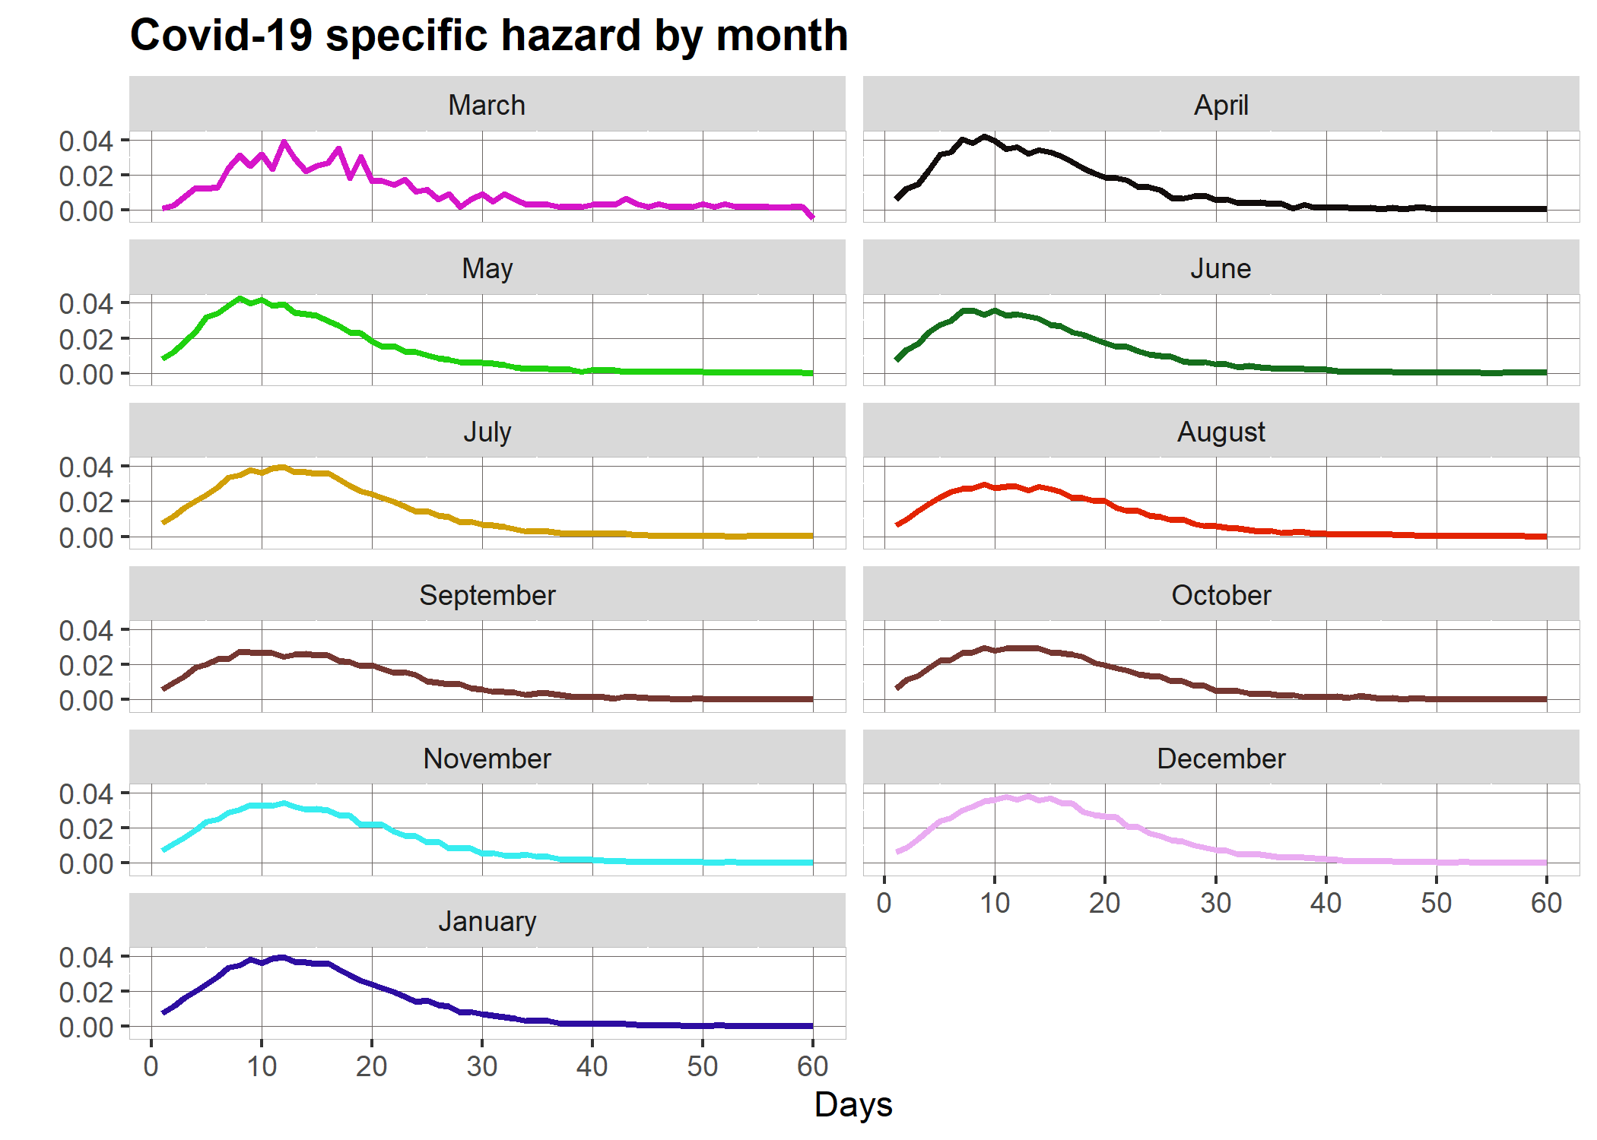

1. Parameter distributions

|  |  |  |  |
| --- | --- | --- | --- |
| **Parameter Distributions for Probabilistic Sensitivity Analysis** | | | |
| Hospitalization costs, not intubated | Value | Distribution | Source |
| Hospitalization time: Not intubated Cohort | μ = 13.29; SD = 7.17 | Lognormal μ = 2.43, σ = 0.51 |  |
| Hospitalization time: Intubated Cohort | μ = 13.89; SD = 13.17 | Lognormal μ = 2.31, σ = 0.80 |  |
| Hospitalization costs $: Not intubated Cohort | μ = 9,272; SD = 3278 | Gamma  α = 8, β= 1159 |  |
| Hospitalization costs $: Intubated Cohort | μ = 44,151; SD = 15,610 | Gamma  α = 8, β= 5519 |  |
| Remdesivir Intervention effect | HR: 0.73, CI: 0.52 - 1.03 | Lognormal μ = 0.73, σ = 0.17 |  |
| Baricitinib Intervention effect | HR: 0.65, CI: 0.39 - 1.09 | Lognormal μ = 0.65, σ = 0.26 |  |
| Dexamethasone intervention effect | HR: 0.64, CI: 0.51 - 0.81 | Lognormal μ = 0.64, σ = 0.11 |  |

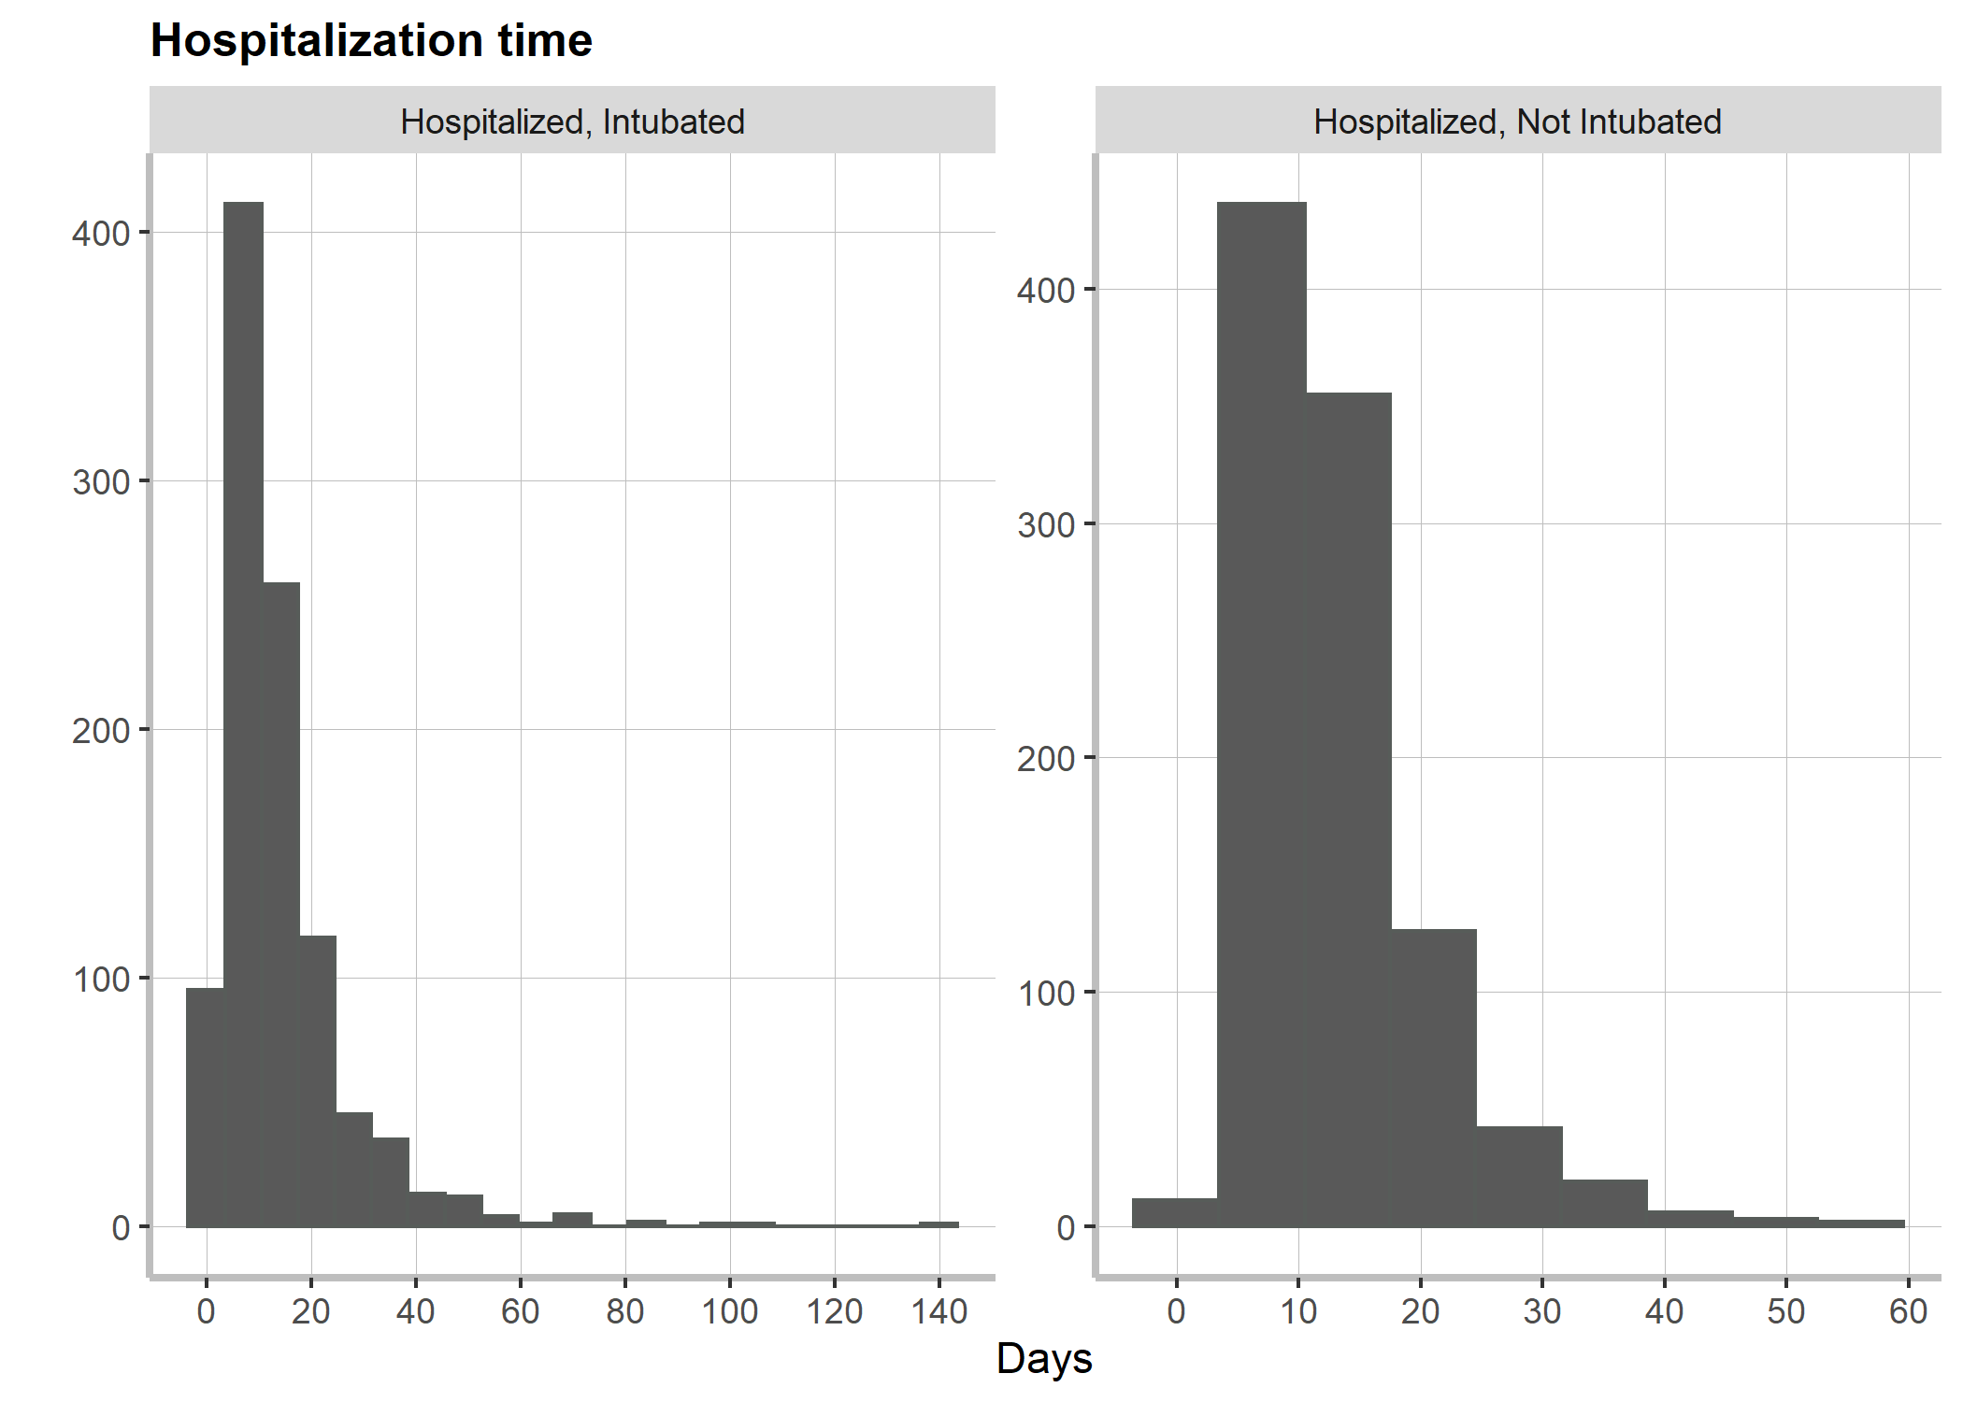

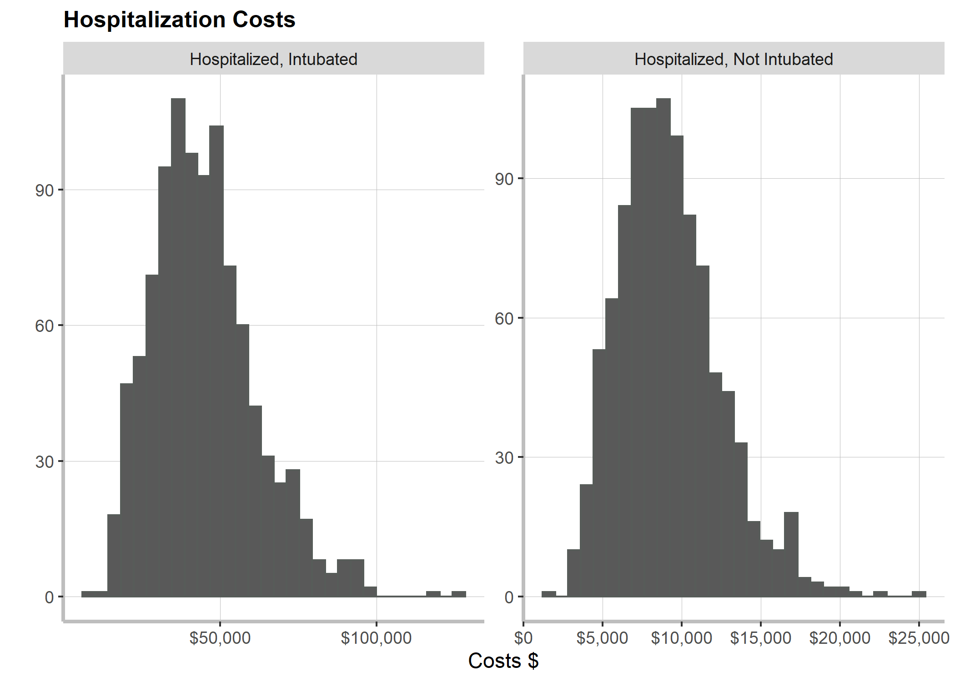

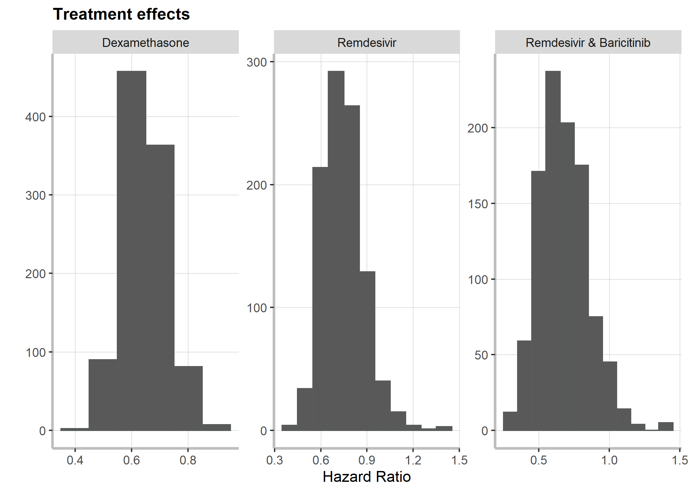

1. Cost-effectiveness acceptability curve, assuming a threshold of $219,806 per year pesos to be cost-effective.

Remarcar las fronteras, y las paso resultados.

Calcular el EVPI para ver como se ve y generar las expected loss curves.

Tabla con QALEs.

Tabla con 50 filas y cuatro columnas, descontado QALEs. Ponlas sin descontar, QALEs (sin el 5%) y con el 5%.

Age and sex specific discounted and undiscounted QALEs entre parenthesis (5%)

Descontadas,